Martins HOT Interface

Part of HOTlab software suit for holographic optical trapping

Quick start guide

Martin Persson University of Gothenburg
January 13, 2011 Rev 2.0 November 16, 2011

martin.persson@physics.gu.se

TABLE OF CONTENTS
1 System setup 3
2 The front panel 4
2.1 The upper pane 5
2.1.1 Stop button 5
2.1.2 Hologram generation controls 5
2.1.3 Status indicators 5
2.1.4 “Run calibration”-button 5
2.1.5 “Display hologram and computed image plane”-button 5
2.2 The lower pane 6
2.2.1 Camera image window 6
2.3 The right pane 7
2.3.1 Group controls 7
2.3.2 Path controls 7
2.3.3 Trap controls 8
2.3.4 Displayed Hologram 8
2.3.5 Calculated image plane 8
2.3.6 Coordinate mapping (IMAQ to SLM) 8
2.3.7 Current trap pos 8
2.3.8 NI Vision error 8
2.3.9 CUDA/SLM error 8
3 Using the program 9
3.1 Starting the program 9
3.1.1 Select camera type 9
3.1.2 Device ID 9
3.1.3 SLM enabled 9
3.1.4 LUT file 9
3.1.5 True frame 9
3.2 Manipulating individual traps 10
3.2.1 To move a trap 10
3.2.2 To create a new trap 10
3.2.3 To delete a trap 10
3.2.4 To alter the Z position or amplitude of a trap 10
3.3 Manipulating a group of traps 11
3.3.1 Assigning traps to a group 11
3.3.2 To translate the group 11
3.3.3 To rotate the group 11
3.3.4 To change the center of rotation for the group 11
3.4 Creating paths 12
3.4.1 To create a single step path: 12
3.4.2 To create a multi step path: 12
3.4.3 To create path with synchronization points 12
3.5 Calibration procedure 13
3.5.1 To calibrate trap positions 13
4 Troubleshooting 14
4.1.1 14
5 References 15

System setup
Install spatial light modulator (SLM) hardware and software provided by Boulder Nonlinear Systems. The software may also be run without SLM hardware for testing purposes.
Download and install CUDA software, “Developer Drivers” and “CUDA Toolkit” are found at: http://developer.nvidia.com/cuda-toolkit-40
If more than one CUDA enabled graphics card is installed, Open the NVIDIA GPU Computing SDK Browser and run “Device Query” to find the device ID of the card that should be used for hologram generation.
Check the “\LabVIEW\DLL archive” folder for a dll version suitable for your system (correct interface and CUDA version) and move that dll to the “\LabVIEW” folder. Versions for SLMs with PCI and PCIe interfaces and CUDA 3.2 and 4.0RC2 were compiled May 10 2011.

The front panel
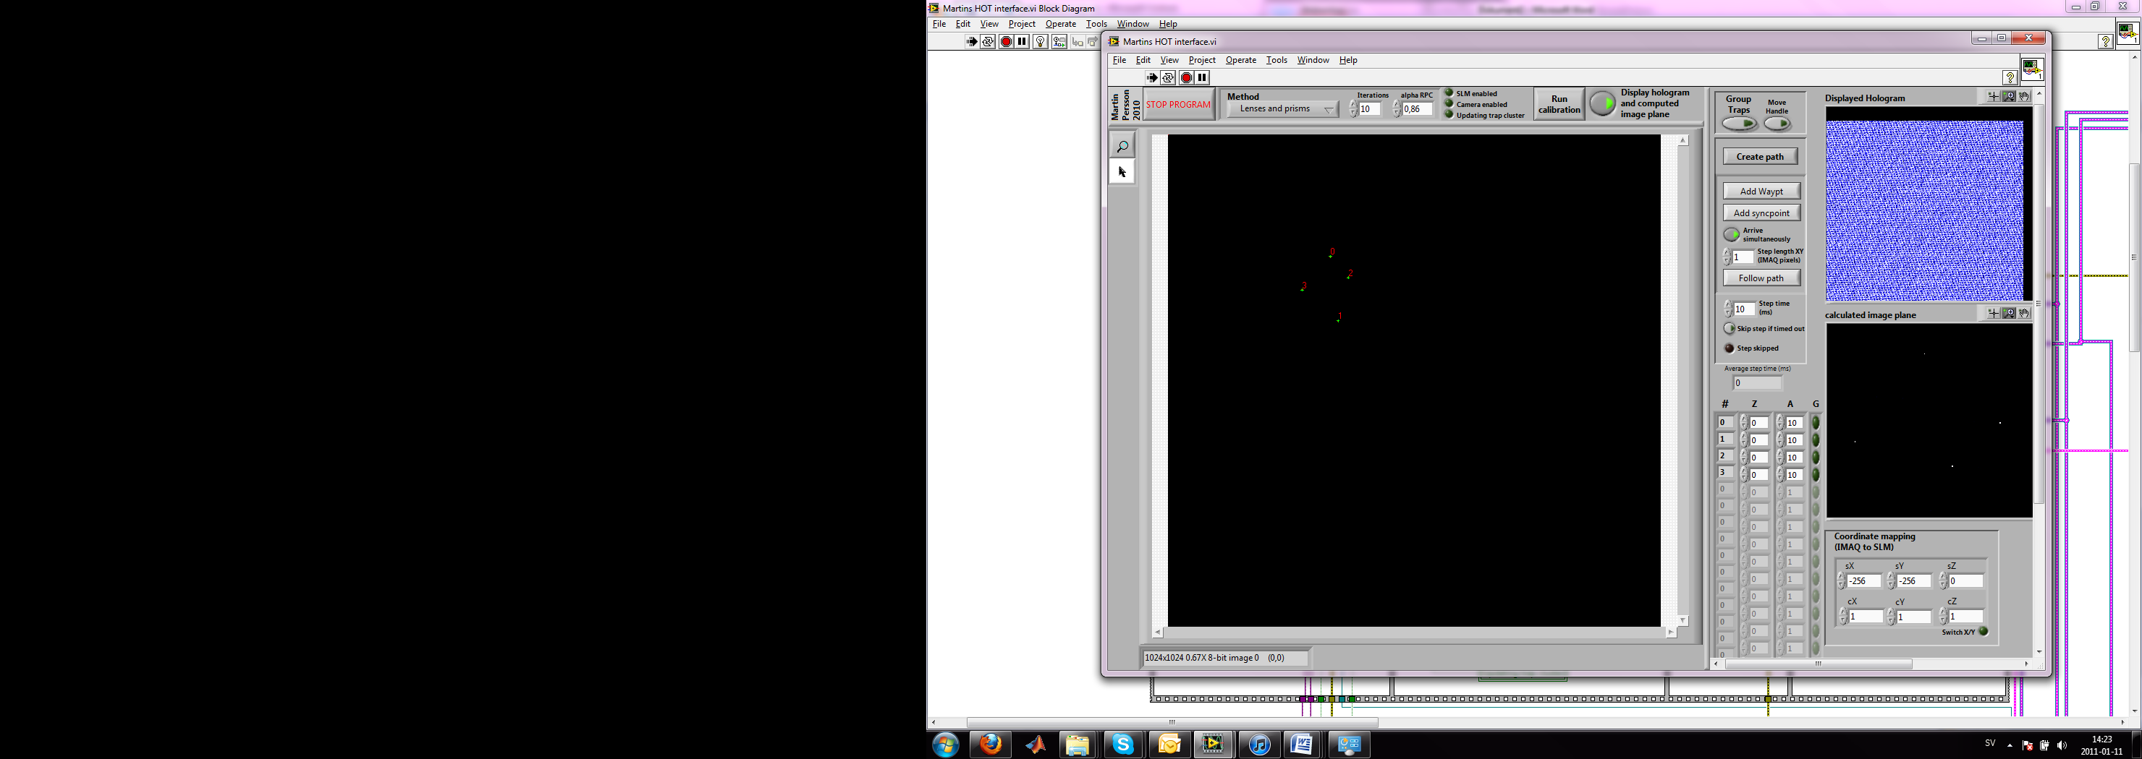
Fig. 1 The front panel
The front panel consists of three separate panes, the The upper pane; The lower pane and The right pane, separated by splitters. The vertical splitter may be dragged to resize the camera image window and to reveal or hide information in the right pane. In the following sections, the items in each pane are listed

The upper pane
Fig. 2 The upper pane
The upper pane contains the following items from left to right:

Stop button
Releases the SLM and CUDA device and stops the program. Always use this button to stop the program, other ways of terminating the program may cause the SLM to fail initializing the next time the program is started.

Hologram generation controls
Allows the user to select method for hologram generation (“Lenses and prisms” or Gerchberg-Saxton (see ref. ), the number of iterations for the Gerchberg-Saxton algorithm and the RPC setting (see ref. ).

Status indicators
The three status indicators shows if the SLM is enabled, if a camera is enabled and if the trap positions (the trap cluster) are currently being updated.

“Run calibration”-button
This button launches the automated calibration procedure described in section .

“Display hologram and computed image plane”-button
When this button is pressed, the latest generated hologram is displayed in the right pane (drag the vertical splitter if not visible) along with the calculated trapping plane and currently used trap positions. See section (2.3.5) for more information.

The lower pane
Fig. 3 The lower pane

Camera image window
The camera image window displays the latest image captured by the camera (or, if no camera is available, a blank image). This is also where the trap positions are selected by the user. Each trap is represented by a “point ROI” (green cross) and may be repositioned by simple click-and-drag operations. The trap number is displayed next to each point ROI. The user may zoom in and out in the image using the zoom tool which is located in the upper left corner of the pane. The camera image window is automatically resized to fill the lower pane.

The right pane
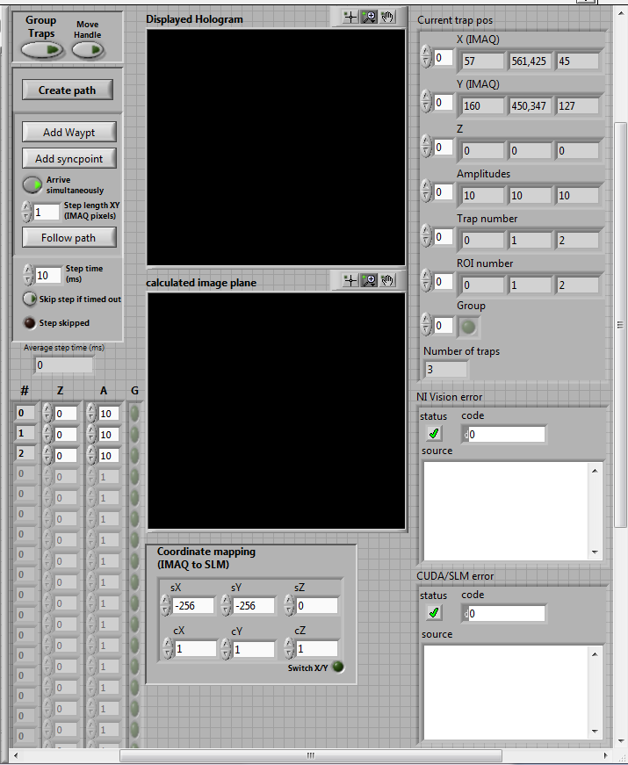
Fig. 4 The right pane
The right pane contains controls for grouping traps, generating pre-programmed paths for traps and changing the intensity and z-position of traps. It also contains a number of indicators and controls that are not necessary for normal operation of the program and may be hidden by dragging the vertical splitter. The items in the left pane are here listed from top to bottom and left to right.

Group controls
When “Group traps” is selected, the traps included in the group (see section 2.3.3) may be repositioned by dragging the group handle see section .
When “Move Handle” is selected, the handle controlling the trap positions may be repositioned relative to the traps.

Path controls
Allow the user to create paths as described in section

Trap controls
The trap controls consist of four columns where each row is assigned to individual traps. The four columns are from left to right:
- The trap number (#) as shown in the Camera image window.
- The trap Z-position (Z). Calibration to real-world units may be done using the 2.3.6 (section 2.3.6).
- The relative trap intensity (I). The actual intensity of the trap also depends on the intensity of all other traps and the total available laser power.
- Trap in group. If this boolean control is set to true, the trap may be manipulated using the group functions as described in section .

Displayed Hologram
Shows the latest generated hologram, which is also displayed on the SLM (if enabled).

Calculated image plane
Shows the intensities in the image plane as calculated by Fourier transforming the generated hologram. Performing the Fourier transform in LabVIEW is time consuming, turn of this display for time critical operations (see 2.1.5).

Coordinate mapping (IMAQ to SLM)
The values in this control determine the conversion from pixels in the Camera image window to position in the image plane. The correct values may be found manually or by using the automated calibration procedure (see section ). sX, sY and sZ are the coordinate shift coefficients and cX, cY and cZ are the coordinate scaling coefficients.

Current trap pos
Show the information in the last “trap cluster” used for hologram generation.

NI Vision error
Shows errors that may have occurred in any of the NI Vision VI:s. Error messages are displayed after the program has been stopped.

CUDA/SLM error
Shows errors that may have occurred when calling GenerateHologramCUDA.dll. Error messages are displayed after the program has been stopped.

Using the program

Starting the program
After opening the main program, press the white arrow in the upper right corner of the main window to start program. An additional window will appear (Fig. 5 The initialization window). Follow these steps before pressing the start button:
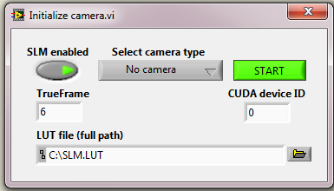
Fig. 5 The initialization window

Select camera type
If a supported camera is available (any camera supported by the NI Vision Acquisition software should work), use the drop down menu to select interface type. IMAQdx supports firewire and GigE cameras while IMAQ supports Camera Link. The program may also be run with no camera enabled.

Device ID
Enter the Device ID (Se section ) of the CUDA device that should be used for hologram generation. If only one CUDA enabled card is installed, the device ID is 0.

SLM enabled
If supported SLM hardware is installed, select “SLM enabled”. If “SLM enabled” is selected, more controls will appear to set up the SLM hardware (Error: Reference source not found):

LUT file
Enter the full path to the .LUT file that was delivered with the SLM or browse for the file by pressing the folder icon. Make sure to use a path with no blank steps.

True frame
See documentation for GenerateHologramCUDA.dll or GenerateHologramCUDA_PCI.dll for information regarding “True Frame”. The default value (6) will work under most circumstances.

Manipulating individual traps
When the program is running in normal operation mode (“Group controls” or “Path controls” not selected), each point ROI in the Camera image window (green crosses) represents a trap position.

To move a trap
Simply click and drag its point ROI.

To create a new trap
Hold down the left ctrl keyboard key and click on the desired position in the image window.

To delete a trap
Right click its point ROI and select “Delete ROI contour”.

To alter the Z position or amplitude of a trap
Use the Trap controls (section 2.3.3) in the lower left part of the right pane. The array indicator labeled ‘#’ indicates the trap number.

Manipulating a group of traps
When “Group controls” is pressed, a handle for the traps in the group appears on the screen and the point ROI:s for individual traps disappears.

Assigning traps to a group
Press the green buttons in the rightmost column in the Trap controls (section 2.3.3). The buttons of selected traps will be highlighted.

To translate the group
Click and drag the center of the handle.

To rotate the group
Rotate group by moving the right side of the handle.

To change the center of rotation for the group
Change the center of rotation by selecting “Move handle” and moving the left side of the handle.
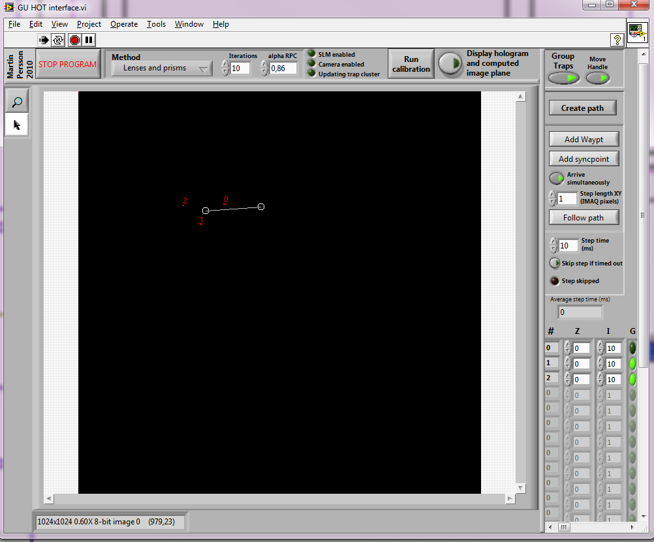
Fig. 6 ”Group traps” activated

Creating paths

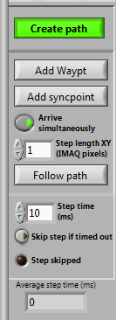
To create a single step path:
Click “Path controls”, move traps to desired final positions and click “Follow path”

To create a multi step path:
- Click “create path”.
- Move traps into desired positions and click “add waypoint”. Continue adding waypoints until path has been completed.
- Enter desired step length and step time.
- Click “Follow path”.

To create path with synchronization points
- Press “create path”.
- Move traps into desired positions and click “add waypoint”. Continue adding waypoints until the first part of the path has been completed
- Enter desired step length and step time for the first part of the path.
- Press “Add syncpoint”.
- Repeat step 2-4 until path has been completed.
- Press “Follow path”
Traps will wait until all traps have reached the positions where synchronization points were added.
Paths may be given different step lengths between each synchronization point.
“Arrive simultaneously” takes effect at each synchronization point.

Calibration procedure
When the program is started for the first time or if the optical system has been realigned, the trap positions in the image window (green crosses) will not match the actual position of the laser spots as captured by the camera. An automated calibration procedure is provided to match real and desired trap positions.

To calibrate trap positions
- Put a reflective flat object in the sample holder of your microscope (e.g. a microscope slide or cover slip) and make sure the reflection of the laser beam is visible on the screen. This may require removal of any filter blocking the laser wavelength from the camera, make sure the laser power is low enough not to damage the sensor chip of the camera.
- Press “Run calibration” upper pane
- Follow the instructions provided in the dialog window.
- If the reflection of the laser spot or the point ROI (green cross) is not visible on the screen, right click and select “Zoom to Fit”.
- Use zoom tool to increase precision when each spot is marked.
Coordinate mapping parameters may also be adjusted manually (Error: Reference source not found).
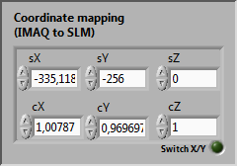
figure 1

To make the obtained mapping parameters default on startup: stop the main program, right click on the “Coordinate mapping” control, select “Data Operations” and “Make Current Values Default”. Press ctrl+S to save changes.

Troubleshooting

Error:
Holograms are not generated and the following message is shown in “CUDA/SLM error”: Call Library Function Node in InitializeGPUandSLM.vi->GU HOT interface.vi
Solution:
Close LabVIEW completely – open, run and close InitializeGPUandSLM.vi - restart the main program

Error
“fatal error C1083: Cannot open include file: 'cutil.h': No such file or directory” appears when compiling the CUDA project.

Solution
Go to Configuration Properties – CUDA Build Rule v3.0.0 – General – Additional include Directories and add : $(NVSDKCOMPUTE_ROOT)\C\common\inc

References

